Name:______________________ Class:________
WEEK 1 Term 2

- What to numbers multiply to 18 and add to 9?

- Narelle arrived at work at 8:40 am and left at 2:15 pm. How long was Narelle at work?

- Ron bought a table during a sale where 20% was taken off the marked price of all goods. The marked price of the table was $1200. How much did Ron pay?

- If t = 3, what is the value of 4t + 5?

- Two towns are 5.6 cm apart on a map? On the map, 1 cm represents 20 km. How far apart are the actual towns?
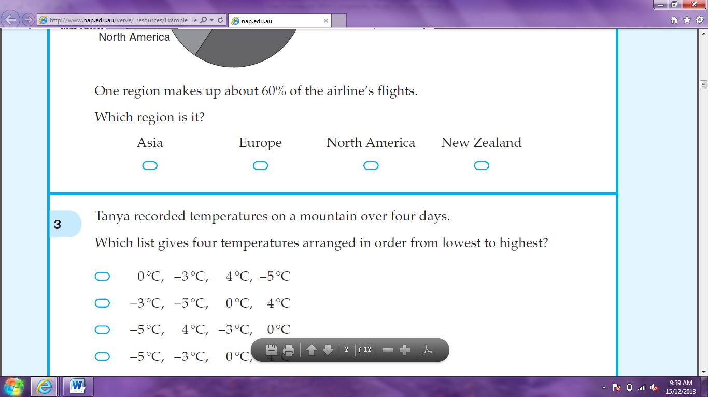



28 km 76 km 112 km 280 km


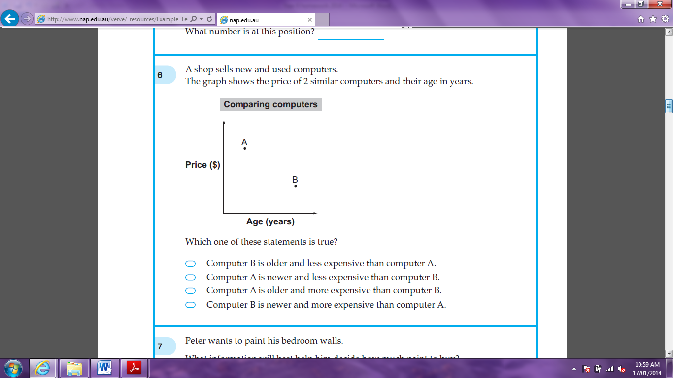
- A shop sells new and used computers. The graph shows the price of 2 similar computers and their age in years. Which on of these statements is true?

Computer B is older and less expensive than Computer A.

Computer A is newer and less expensive than Computer B.

Computer A is older and more expensive than Computer B.
Computer B is newer and more expensive than Computer A.


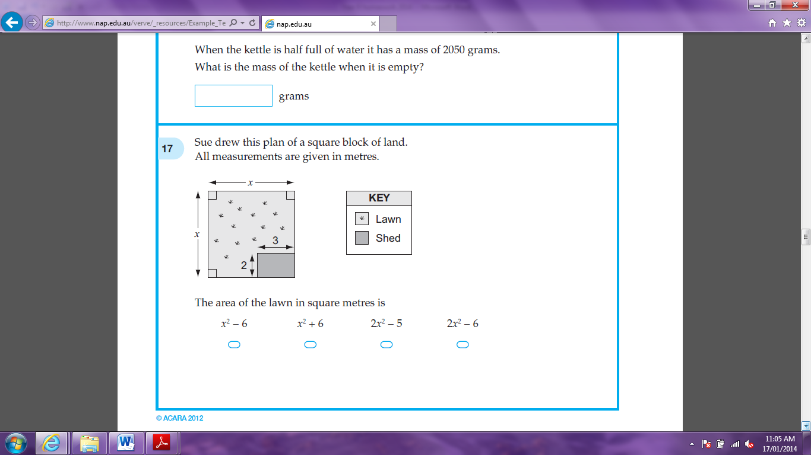
- Sue drew this plan of a square lock of land. All measurements are given in metres. The area of the lawn in square metres is:

x² – 6

x² + 6

2x² – 5
2x² – 6




- Natasha is drawing a rectangle on a grid. She has marked three of the points. Where will the fourth point go?
(2, -4)
(-2, 4)
(4, -2)
(-4, 2)

- What is the rule connecting x and y?
x | 1 | 2 | 3 | 4 | 5
y | 1 | 4 | 7 | 10 | 13





y = x y = 2x – 1 y = 3x – 2 y = 4x – 3


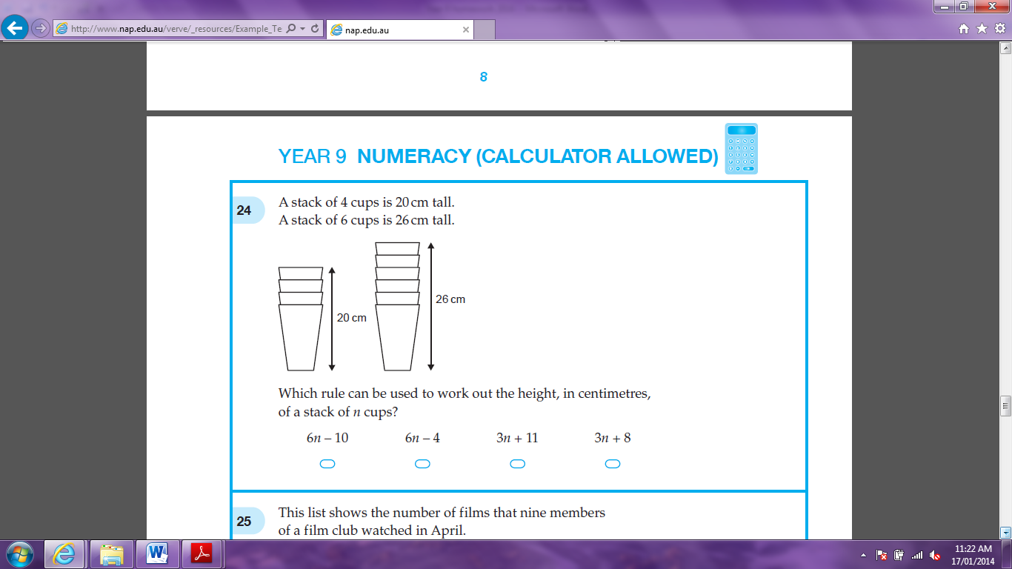
- A stack of 4 cups is 20 cm tall. A stack of 6 cups is 26 cm tall. Which rule can be used to work out the height, in centimetres, of a stack on n cups?

6n – 10

6n – 4

3n + 11
3n + 8

- What is the value of ?

- Jason uses these formulas to calculate how the money in his bank account grows.
What is the value of

- What is the value of z?

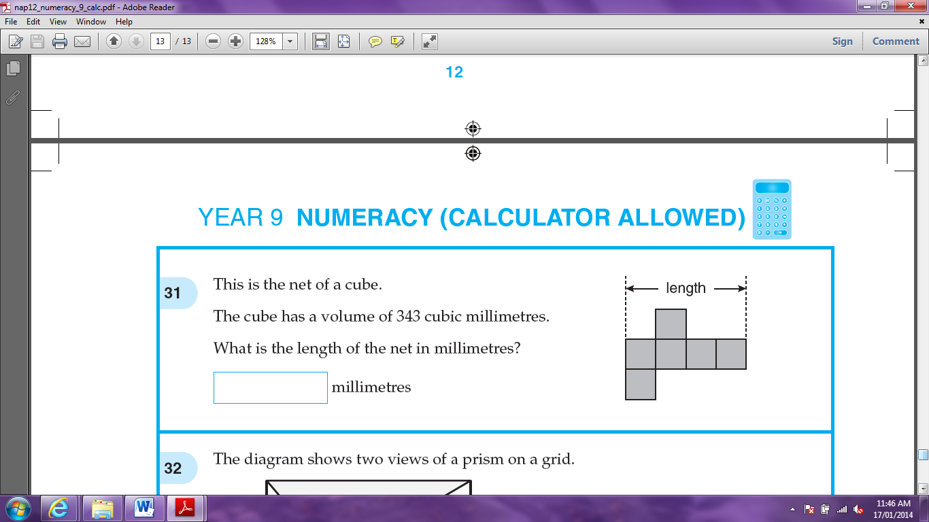
- This is a net of a cube. The cube has a volume of 343 cubic millimetres. What is the length of the net in millimetres?

- The average height of six netball players is 1.75 metres. A seventh player is 1.61 metres tall. What is the average height of the seven players?

